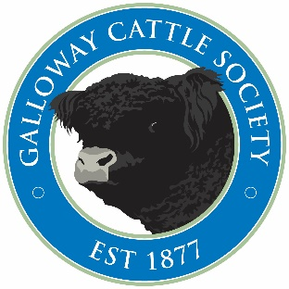 15 New Market Street, Castle Douglas
DG7 1HY
Tel - 01556 502753
Mob - 07760623985
info@gallowaycattlesociety.co.uk
www.gallowaycattlesociety.co.uk

Dear Member
I hope you are well and enjoying some freedom from restrictions which are very welcome especially as we have been blessed with better weather.
Following our recent Trustee’s meeting held after our AGMs I would like to inform you of the following changes:-
NEW CHAIRMAN
I am delighted to inform you that Mr Allan McClymont, Kirkstead, Yarrow has been elected as Chairman of the Society, with Mr Peter Hunter Blair, Nether Cleugh the new Vice Chairman and Mr Robert McTurk Barlaes taking the role of Junior Vice Chairman. If you have any questions or suggestions please do not hesitate to contact any of the above. Our grateful thanks to the outgoing Chairman Mr Duncan Maxwell, Ben Lomond.
VERIFYING SIRES
As you know, the Society has been DNA profiling sires for many years, the next step is to confirm sires of newly registered bulls, there will be no additional charge for this, but it means all male registrations will be required to be accompanied with a DNA hair sample, if we don’t receive a DNA sample we will be unable to issue the Pedigree Certificate. You can also request heifers to be sire verified at the same cost of £36,(inc Vat) this is not compulsory but is especially important if females are exported. Please contact the office for a supply of DNA sample bags. This new sire verifying service will commence from the 1st June, 2021.
Pedigree Certificates
Due to increased cost of postage, it was a unanimous decision to email pedigree certificates to all members unless postage is requested and paid. Pedigree certificates will be emailed to the email address held in our database, so please ensure we have your current email address. This will commence from 1st September 2021.
Slaughter Certificates
With the increased demand of Galloway Beef, retailers are requesting parents are verified as Galloway, to overcome this for unregistered heifers (as long as the animal is from registered parents) we will provide a Slaughter Certificate for the same price as a steer certificate of £12. You will be unable to register any progeny and the record will not appear in the herd book. Please contact the office if you require either a slaughter or steer certificate.
If you have any questions or queries, please do not hesitate to contact me either by email or mobile.
Kind regards
Dorothy Goldie
Breed Society Secretary

